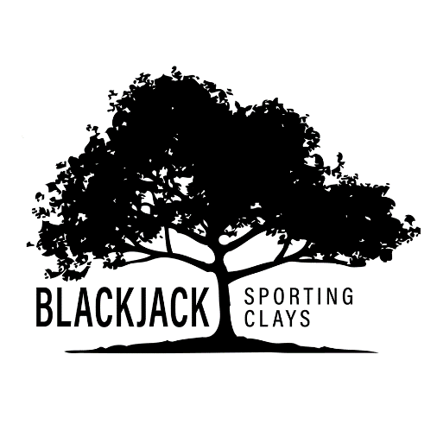

**2025 Member Pricing**

Sporting Clays .42/clay

Trap .42/clay

Skeet .42/clay

5-Stand .42/clay

**Rentals**

Golf Cart $20

Push Cart $5

Gun $20



3372 CR 572, Sumterville, FL 33585

(352) 569-9469 [info@blackjackclays.com](mailto:info@blackjackclays.com)